

**NYCTANTHES ARBOR-TRISTIS**

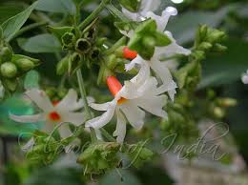**BOTANICALNAME: *Nyctanthes arbor-tristis***

**FAMILY:** Oleaceae

**SYNONYMS:**

**ENGLISH:** night jasmine

**HINDI:** Harsingar

**TAMIL:** parijaat

**TELUGU:** Pārijātam

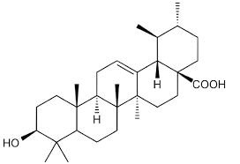

**CHEMICAL CONSTITUENTS:**

Iridoid glycosides, mannitol, beta-amyrin, beta-sitosterol, hentriacontane, benzoic acid, astragalin, nicotiflorin, oleanolic acid, nyctanthic acid, friedelin and lupeol.

**USES:**

* Parijatham is often used in traditional medicine to aid digestion. It is believed to have properties that help in relieving constipation and improving overall digestive function.
* It has anti-inflammatory properties, making it useful in treating conditions related to inflammation, such as arthritis.
* The flowers and leaves are sometimes used in treatments for skin conditions, including eczema and acne, due to their purported antimicrobial properties.
* In some regions, the flowers are used as a natural flavoring agent in certain dishes and desserts. Their fragrance can enhance the flavor profile of culinary preparations.
* The pleasant aroma of the flowers makes them suitable for use in aromatherapy and natural perfumery.
* The flowers can be used in traditional crafts, such as making garlands and decorative arrangements for festivals and ceremonies.