

**CORIANDERSATIVUM**

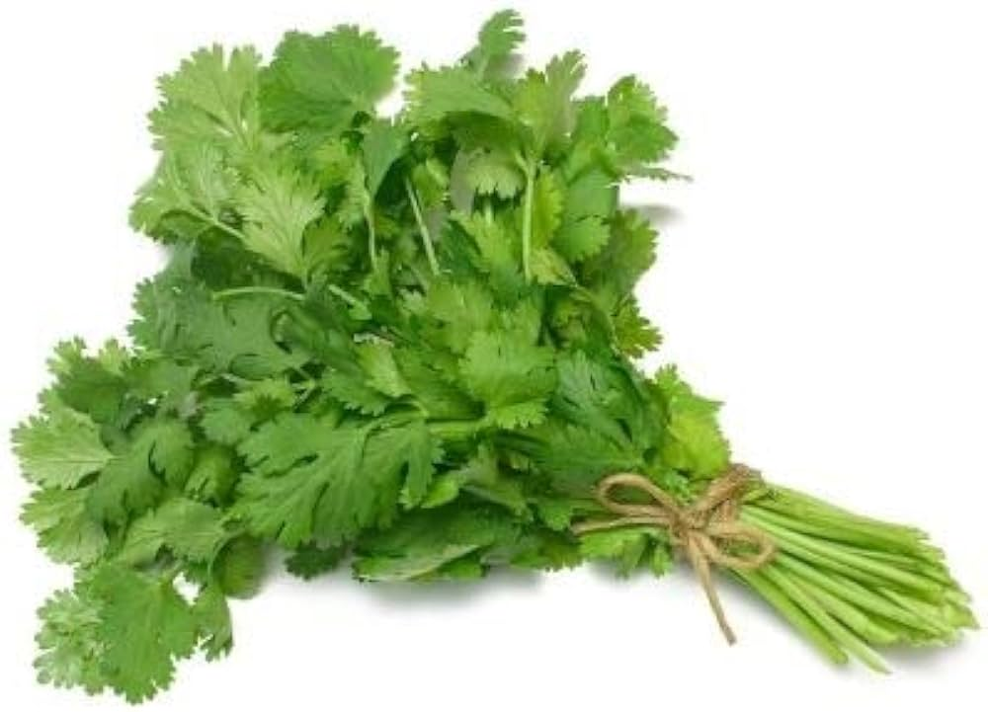**BOTANICAL NAME: *Coriandrum sativum***

**FAMILY:** Apiaceae (Umbelliferae)

**SYNONYMS:**

* + **ENGLISH:** Cilantro
  + **HINDI:** Dhaniya
  + **TAMIL:** Kothamalli
  + **TELUGU**: Kottimīra

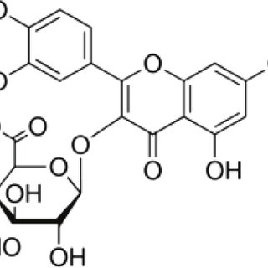**CHEMICAL CONSTITUENTS:**

* linalool (72.7%) followed by λ-terpinene (8.8%), α-pinene (5.5%), camphor (3.7%), limonene (2.3%), geranyl acetate (1.9%) and p-cymene (1.5%).

**USES:**

* Coriander, also known as cilantro in its leaf form and coriander seeds when dried, is incredibly versatile and used in various ways across different cuisines:
* Often used as a garnish or mixed into dishes for a fresh, citrusy flavor. Common in Latin American, Middle Eastern, and Asian cuisines. It's great in salsas, salads, and as a topping for soups and stews.
* Used as a spice in many dishes. They can be toasted to enhance their flavor and ground into a powder. Popular in spice blends like garam masala and curry powder, as well as in pickles, marinades, and spice rubs.
* Adds a unique, bright flavour to dishes. It pairs well with a wide range of ingredients, from vegetables and meats to grains and legumes.
* Coriander seeds are believed to aid digestion and can be used to alleviate bloating and discomfort.
* Both the seeds and leaves have properties that may help reduce inflammation and oxidative stress.